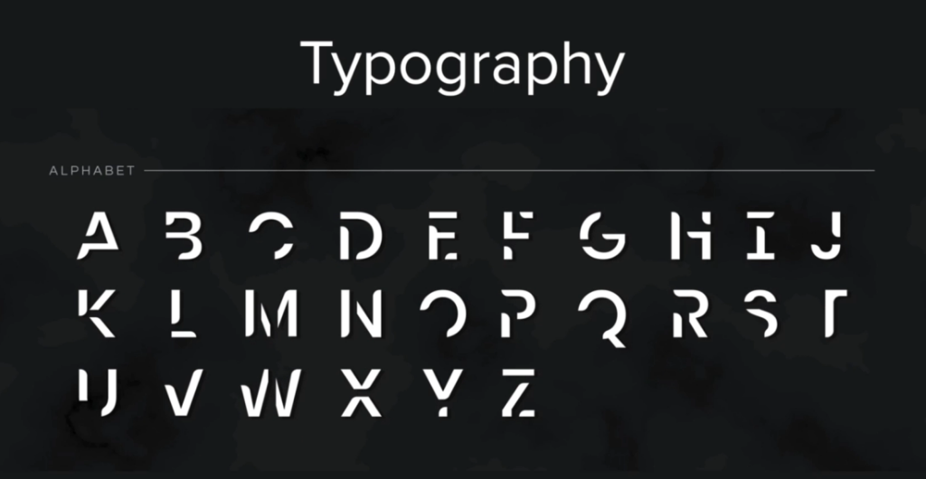

SERIF – Serious, older sites

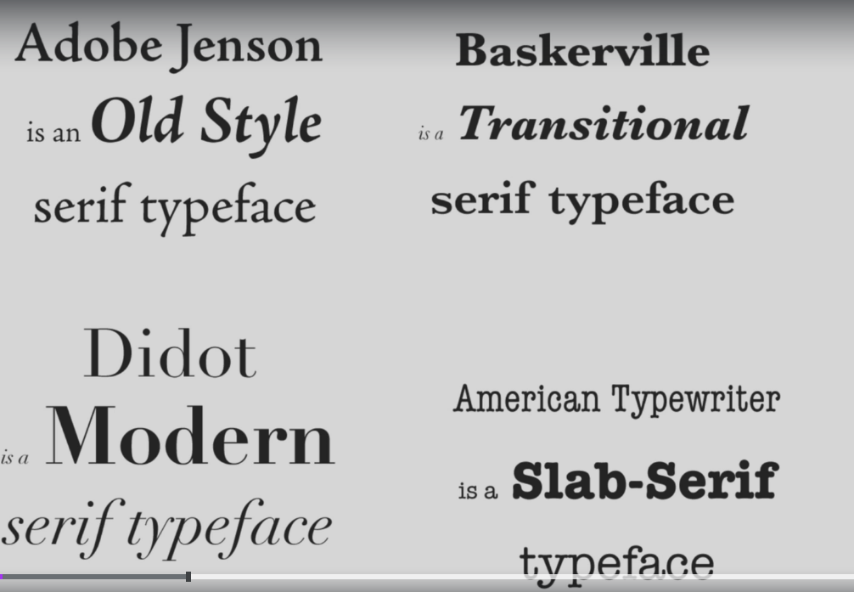

Solo 2 fonts en 1 diseño, con similar modos

